minutes
University Council Meeting

November 20, 2024
8:00 am

Attendees:
Brigitte Grant, Chandra Alston, Charleen McNeill, Charlie Snyder, Cindy Russell, Donald Thomason, Jessica Snowden, John Cox, Ken Tilashalski, Nicholas Verne, Paul Wesolowski, Peter Buckley, Reginald Frye, Steve Alway, Micheal Alston, Robert Craft, Michael Ebbs, James Haynes, Debbie Long, Tracy McClinton, George Ninan, Frank Lancaster, Wesley Byerly, Vikki Massey, Margaret Bohm

Absent:
Wendy Likes, Raaj Kurapati

Dr. Buckley called the meeting to order 8:00 am central.

Chancellor (Dr. Buckley):
- Recruitment – Vice Chancellor of Strategic Communication and Marketing search meeting will kick off December 13th, with Brigitte Grant chairing and Maureen O’ Connor from Le Bonheur co-chairing; Raaj and Reggie co-chairing College of Medicine Dean search – upcoming Zoom interviews.
- Inclement Weather Policy- Be sure to communicate to faculty and staff.
- Marketing & branding UT Health Science Center – Strategically we are now focusing promoting the utilization of “UT Health Science Center” (in preference over UTHSC) for branding and greater recognition across all campuses and externally. While of course there are a few select situations, such as our domain name, where UTHSC will still be seen, we are being intentional in making all reference to the university with Health Science Center written fully.

Legislative Priorities- Tim Sigler:

- While we of course support individual speech and advocacy, we have an explicit policy that guides our legislative activities at local- state-federal levels.
- Please review and share
https://policy.tennessee.edu/policy/ge0003-state-and-federal-government-relations-activities/

Summary of 11/15/2024 Retreat- Cindy Russell and Brigitte Grant:

- Philanthropy sessions were very informative and looking forward to building new friendships that will bring about big ideas to raise money collectively and increase enrollment.

Philanthropy- Family Campaign- Brigitte Grant:

- Great start everybody on supporting Cherisa and Caitlin with this noble mission- Giving Day- Surpassed donor goal of 1,000 at 115.5% with 1,155 donors raising $664,850. Donors increased 12.2% from 2023: Online dollars increased 16.8% from 2023; Offline dollars increased 15.8% from 2023. 100% giving from Advisory Board.
- Family Campaign 2024 Recap- 765 total donors,109% of donor goal reached, 141 more donors than last year-22.5% increase, participants have more than doubled in three years.
- Creating a Culture of Philanthropy- New student initiative, reunion giving, implantation of Leadership annual giving and utilizing all-campus alumni weekend to prepare for Giving Day beginning in FY26.

Audiology and Speech program (ASP) video- Steve Alway:

- Video Presentation- Students, patients and community leaders gave testimonials of how proud they are with the program and the great launch of the new building-UT Conference Center that shows high quality and visibility of their work, ASP- a great program.
- 2024 Department Video from Big Slate Media

Communications form this meeting back to our colleagues and friends

Resolution in Gratitude- Presented by Dr. Tracy McClinton, President of Faculty Senate
The University of Tennessee Health Science Center Faculty Senate expresses its gratitude to Chancellor Peter Buckley, Vice Chancellor Cindy Russell, Executive Vice Chancellor Raaj Kurapati, Vice Chancellor Paul Wesolowski, and the members of their staffs for the efforts they are expending to develop inclusive culture in which the Administration, Faculty and Staff are working together as a team moving the University of Tennessee Health Science Center into the future. The
- UT Oklahoma football tail gating party
- Individual college and campus town meetings
- Chancellor’s Office Hours
- Inclusion of faculty and staff representation in high level administrative meetings
- Publishing minutes of high-level administrative meetings
- Faculty Senate Executive Committee Leadership reception
- Celebration of Promotion and Tenured Faculty
are firsts and deeply appreciated. They represent clear evidence of Dr. Buckley’s commitment to and appreciation for his constituencies and genuine shared governance. The Faculty Senate commits itself to working enthusiastically with the Administration to continued development of these inclusive objectives.

Happy Thanksgiving!!!

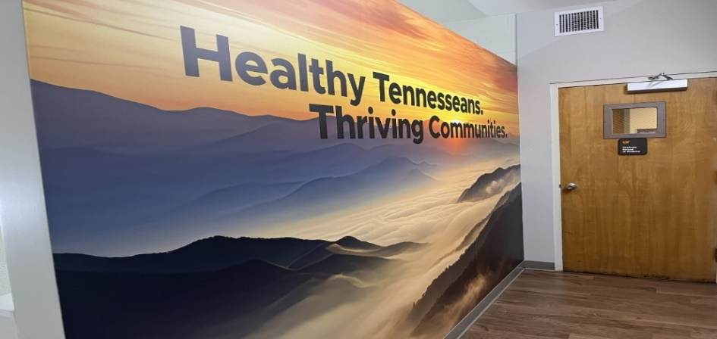

Courtesy of- Robert Craft, College of Medicine

Meeting Adjourn at 9:30 am central

