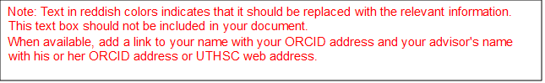

University of Tennessee Health Science Center

Master of Science Thesis/Doctoral Dissertation

**Thesis/Dissertation Title**

**Only 3 Lines Allowed,**

**All Bold, Title Case Capitalization**

|  |  |
| --- | --- |
| *Author:* Your name as enrolled | *Advisor:*  [Advisor Name, Highest Degree](https://www.uthsc.edu/pharmacology/faculty/Liao.php) |

*A Thesis/Dissertation Presented for The Graduate Studies Council of*

*The University of Tennessee Health Science Center*

*in Partial Fulfillment of the Requirements for the Master of Science/Doctor of Philosophy degree from*

*The University of Tennessee*

*in*

*Program: Track*

*College of Graduate Health Sciences*

*Month and Year of Final Approval for Graduation*

Copyright © 2023 by John Q. Student.

All rights reserved.

Disclaimer: This document follows the formatting requirements of the UTHSC Alternative Thesis/Dissertation Guidelines for AETDs instead of the standard UTHSC Electronic Theses and Dissertation (ETD) Guidelines.